Physical Menu

Path : billing.petpooja.com >> Menu >> menu & Discounts >> Physical Menu.

outletwise_link : https://menu.petpooja.com/menus/physical_menu/

Steps to reach Physical Menu:
Step 1 : billing.petpooja.com in Steps to reach Physical Menu : Open your browser and go to billing.petpooja.com.
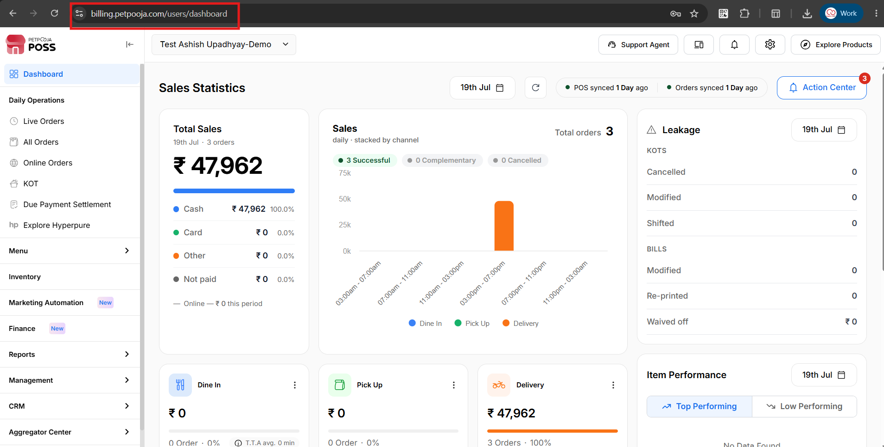
{Image Name: PetPooja Dashboard,
Description: The highlighted URL indicates that this is the billing.petpooja.com. Here is an image of Step 1 billing.petpooja.com in Steps to reach Physical Menu}
Step 2 : Menu in Steps to reach Physical Menu : From the dashboard, click on the Menu option.
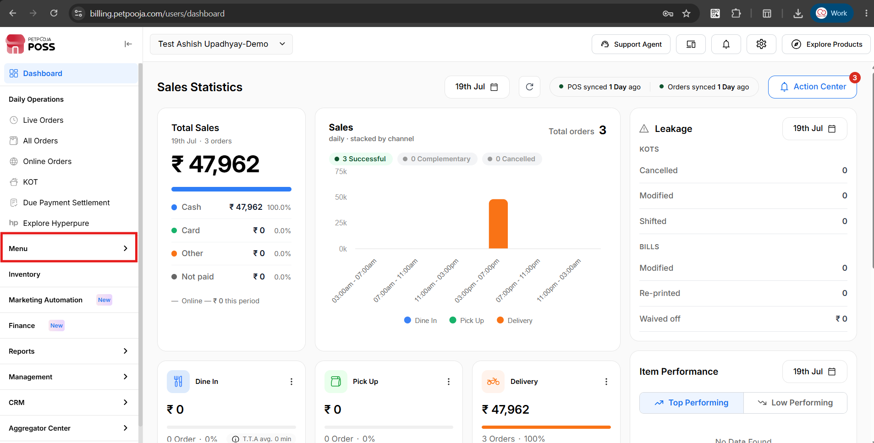
{Image Name: Menu Section,
Description: The image shows the POS dashboard with the "Menu" section highlighted in the left sidebar, used to access menu-related settings and management options.Here is an image of Step 2 menu in Steps to reach Physical Menu}

Step 3 : Menu & Discounts in Steps to reach Physical Menu : Select Menu & Discounts.
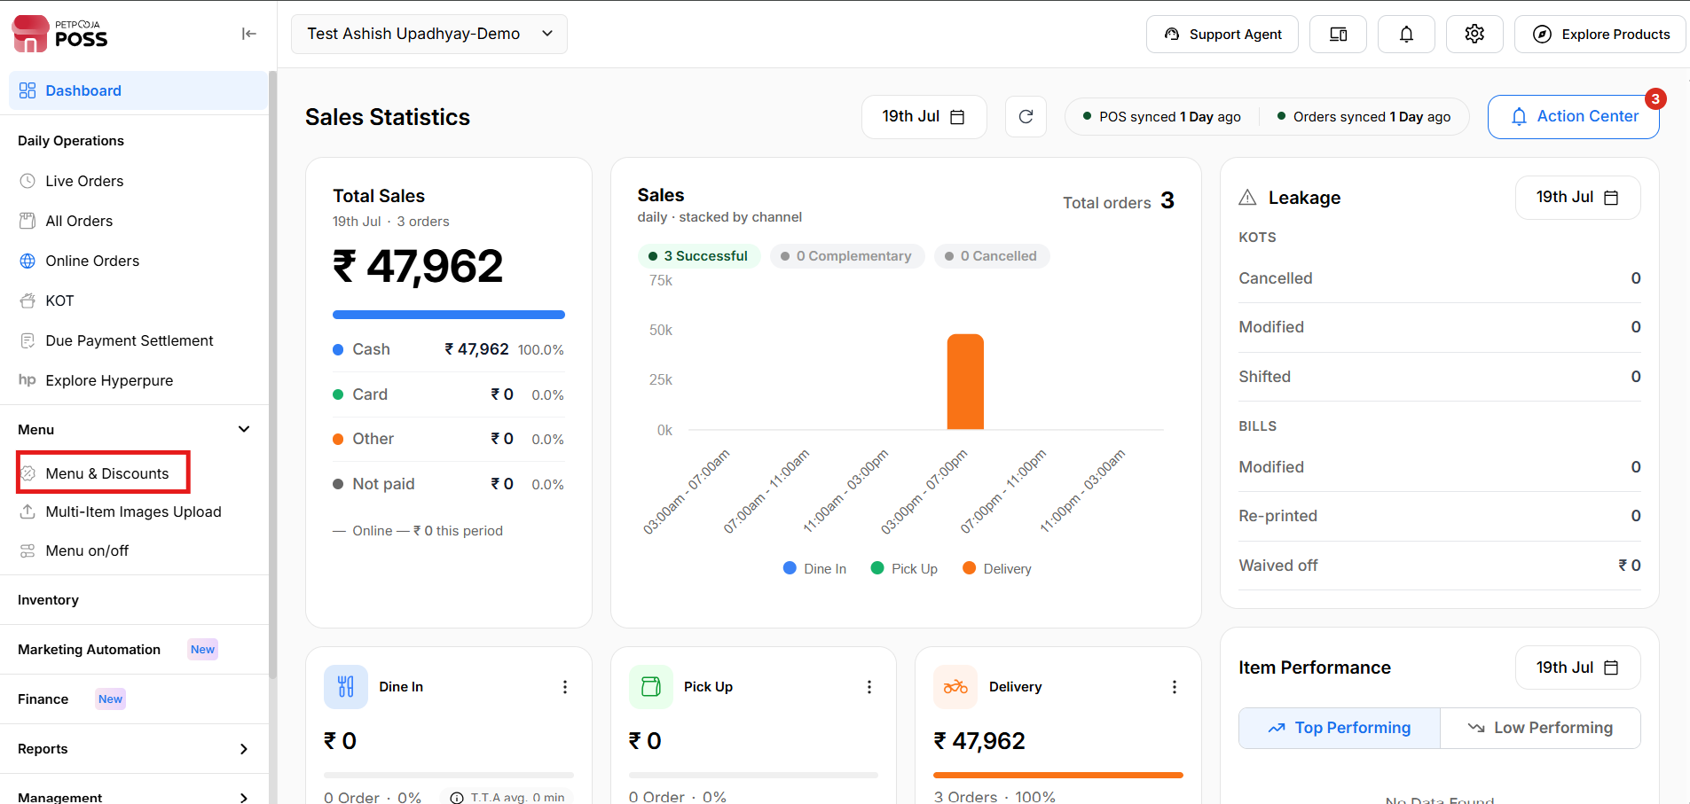
{Image Name: Menu & Discounts Section,
Description: The image shows the POS dashboard with the "Menu & Discounts" option highlighted in the sidebar for managing menu items and discount settings.Here is an image of Step 3 Menu & Discounts in Steps to reach Physical Menu}
Step 4 : Physical Menu in Steps to reach Physical Menu : Click on Physical Menu to view, manage, or print your restaurant’s physical (offline) menu.
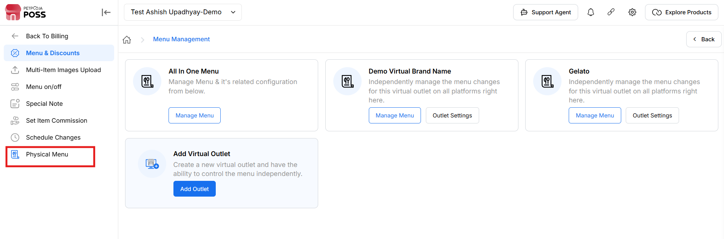
{Image Name: Physical Menu Management,
Description: The image shows the POS menu management interface with the "Physical Menu" option highlighted, used to manage the physical (in-store) menu configuration.Here is an image of Step 4 Physical Menu in Steps to reach Physical Menu}

Key features of Physical Menu :

To add a Physical Menu:
If you want to store your menu for reference, you can upload it in the Physical Menu section. This is only for saving your menu files and images.
Steps:
- Click on Add File.
- Click Browse and upload your menu file or image.
Note: (You can upload JPG, JPEG, PNG, or PDF files — max size 15MB)
- Click Upload. Your menu will be saved in the Physical Menu section.
This helps you keep your menu stored safely for future reference.
outletwise_link : https://menu.petpooja.com/menus/physical_menu/

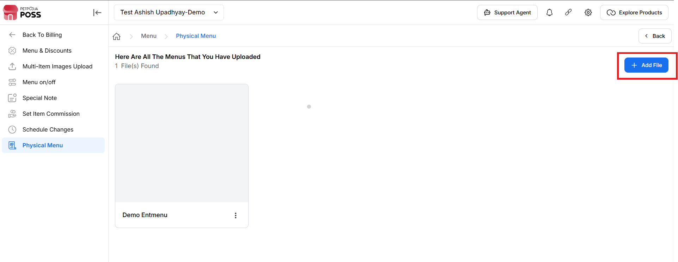
{Image Name: Physical Menu File Upload,
Description: The image shows the Physical Menu section of the POS where users can add and upload menu files, with an option to add a new file when no records are found.}

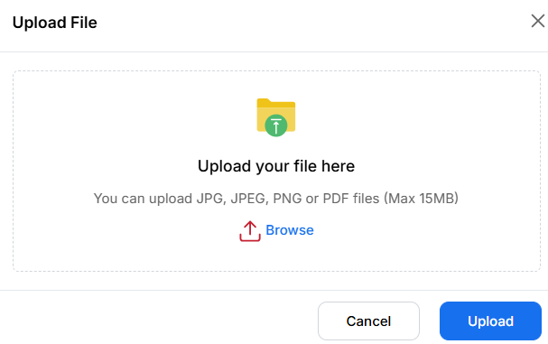
{Image Name: File Upload Popup,
Description: The image shows a file upload dialog box where users can browse and upload JPG, JPEG, PNG, or PDF files up to 15MB in size.}

